Cycle Test Summary

Goals:

The goal of the cycle test is to learn the basics of battery charging ultimately leading to a battery management plan. Some specific goals are to produce a curve similar to the datasheet, to experimentally measure internal resistance, and to confirm the lifetime of the batteries.

Our batteries are: LiFe-PO4 (APR18650M1A)

Datasheet: <http://www.a123batteries.com/v/vspfiles/images/pdf/APR18650M1A.pdf>

Notable information:

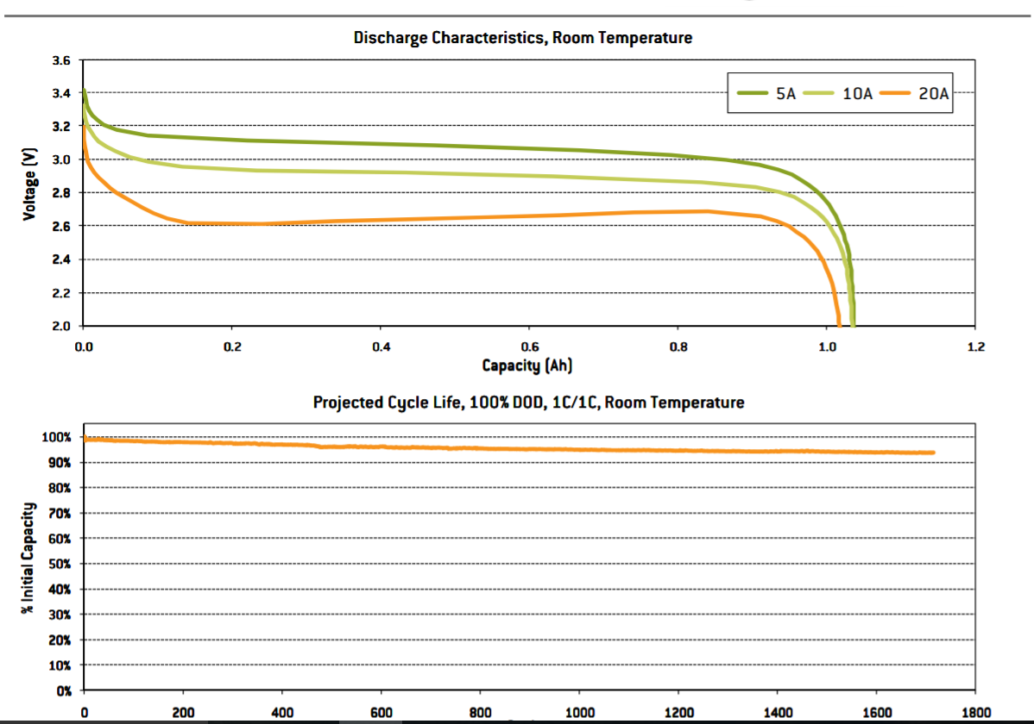

Graph 1 and 2

Summary

We entered this test with some wrong assumptions about the way battery charging works. We assumed we would see a graph similar to the datasheet while charging and discharging simply by measuring the voltage during the process. Instead we discovered that there is a large rise/drop in voltage that is associated with charge/discharging.

Week #1

Setup:

This setup was only supposed to test the coulomb counter and our code it did not have the ability to switch between charge and discharge. It consisted of 2 batteries in series, the battery board V2 as a simple holder, the coulomb counter breakout board, a fan on a heat sink, and 2 12 ohm resistors in parallel to allow the batteries to discharge at 1 amp. Plus an Arduino to communicate with the coulomb counter.

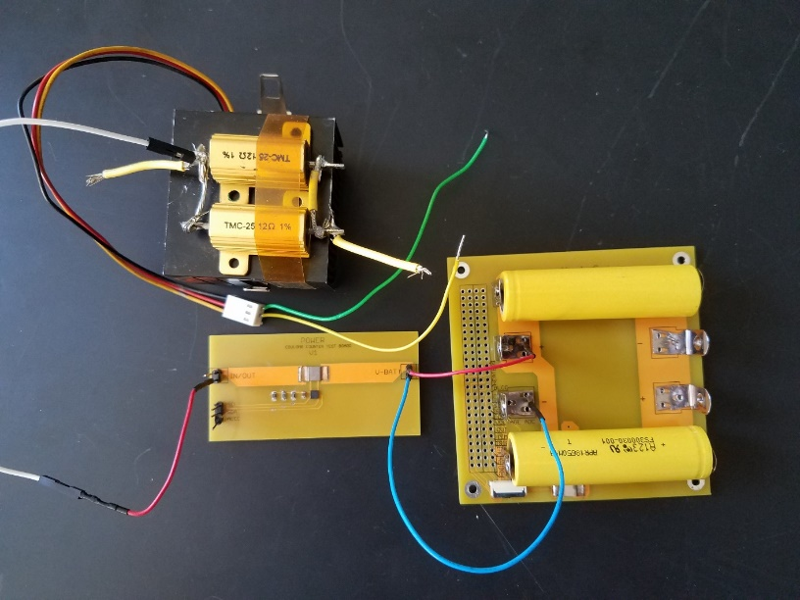

Figure 1

Takeaways:

Graph 3 shows a battery that was initially discharged being charged at 1.5A (initially) until the charge current drops to .3A. At this point we didn’t know about the sudden rise in voltage associated with charging. We expected to get a graph similar to the datasheet, instead you can see that:

* The battery reaches its max voltage (7.2V) after only 600mAh (the size of the battery should be 1100mAh) after which the Constant Voltage limit kicked in and the current reduced.
* The artifacts (square jumps) in the graph were created by limiting the current below 1.5 amps which instantaneously lowered the voltage, which showed that the voltage rise is proportional to charge current.

Together that means that we will not be able to use the battery voltage as a reliable source of information, instead we will have to watch the current into the battery to determine if the battery is full.

Graph 3

Week 2:

The next iteration of the setup included a relay to switch between charging, discharging, and open circuit voltages.

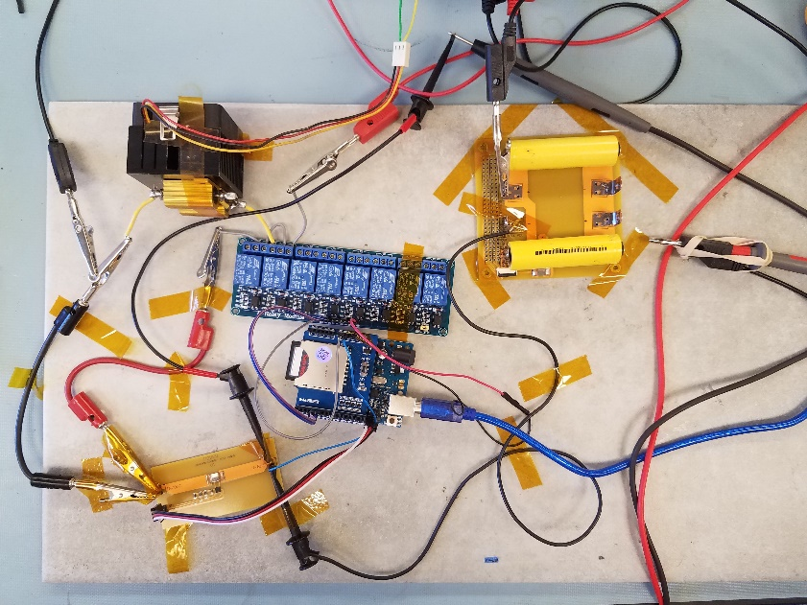

Figure 2

Takeaways:

With this setup we were able to periodically measure the open circuit voltage to get a graph similar to the datasheet.

Graph 4

Graph 4 shows a partial charge of a mostly dead battery. The graph shows two trends, the voltage measured while charging (Top) and the voltage when the circuit is open (Bottom). The bottom graph clearly follows the datasheets trend and it if had continued it may have shown the open circuit voltage approaching the 7.2 limit.